***Router Configuration***

**Objectives:**

1. To have a better understanding on the functions of routers and switches.
2. To get familiar with basic commands used in configuring Cisco router.
3. To get familiar with setting up an enterprise network.
4. To gain experience in configuring router.

**Equipment Required:**

1. Two PCs
2. Two Cisco 1941 routers
3. Two Cisco 2960 switches
4. Straight Ethernet cables
5. Console cables

**Network Setup**

To setup the network,

* Using a straight cable, connect the ethernet interface port on PC1 to interface port f0/1 of the Switch1.
* Using a straight cable, connect interface port f0/23 of the switch1 to interface port g0/0 of the Router1.
* Connect PC2 to Switch2 and Switch2 to Router2 as you did in the previous steps.
* Using a straight cable, connect interface port g0/1 of the Router1 to interface port g0/1 of Router2.
* To configure the router, it is necessary to connect a PC to the Router by means of a console cable. Use the comm port (serial port) available on the PC to connect to the console port of the Router.
* Check that you have a network similar to the one in figure 1.
* Make sure that all the devices are powered up. Switch off the firewall on both PCs.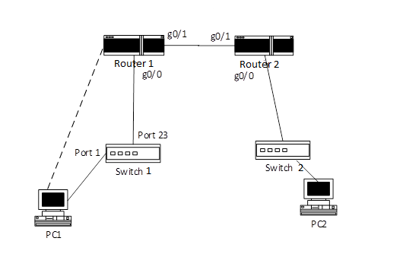

Figure 1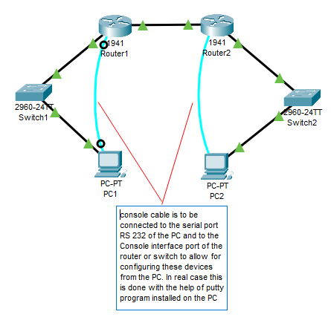

**Part B. IPv4 network configuration**

With the network set up as above, the next step is to configure the router and PC.

|  |  |  |  |
| --- | --- | --- | --- |
| **Router Name** | **g0/0** | **g0/1** | **Subnet mask** |
| Router 1 | 152.1.25.1 | 150.10.20.1 | 255.255.0.0 |
| Router 2 | 152.2.25.1 | 150.10.20.2 | 255.255.0.0 |

**Cisco Router Setup**

1. Click on PC1 in the workspace then click on Desktop from the top menu bar then click on Terminal icon.
2. In the Terminal window check that the *speed* is set as 9600 and click OK to open the configuration command line window → answer “no” to the initial configuration dialog question → Hit the enter key on your keyboard and you are now in *user mode*

1. Type ***enable*** to enter the *privilege exec mode*.

Again, type “?” to get help on the commands available. Compare the list with the one that you have previously in the user mode. You should see more commands are available to you. Note that you can also get partial help if you know the commands but not the parameters following the commands. To get help in such a case, type **?** after the command. E.g. **show ?** (this will provide you with a list of items that you could display with more information.)

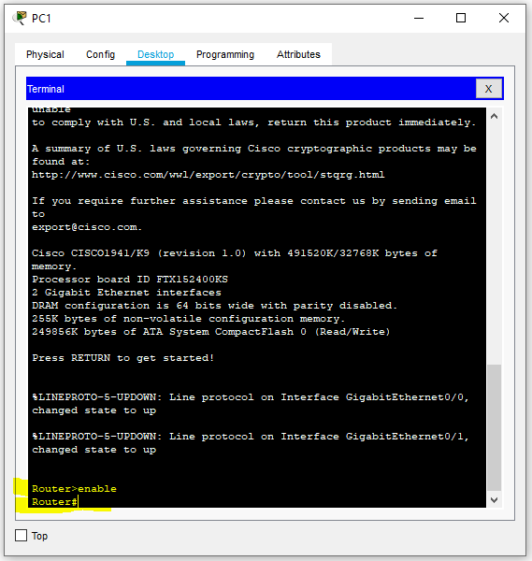

1. Check the system setting by typing ***show running-config***. Note that in general, abbreviations are allowed as long as there is no confusion. Here, you could type ***sh run*** instead. Press space bar to display more information on the screen.
2. The following table summarizes the commands that you will use to configure the routers. Take note on **how the prompt changes after entering a command**. After **reading** through the commands and the examples, go to step 6 to begin configuring the router.

**To enter into the Privileged Exec Mode**

Router>*enable*

Password: *csis*

Router#

**From the Privileged Exec Mode to Global Configuration Mode**

Router#*config term*

Router(config)#

# To set an identification (e.g. give the name “Lab-A”) for the router

Router(config)#*hostname Lab-A*

Lab-A(config)#

# To configure an interface

**command: interface *interface-type* *interface-number***

**e.g. for GigabitEthernet interface 0/0, use *g0/0*; for FastEthernet interface 0/1, use *f0/1*, etc.**

Lab-A(config)#*interface g0/0*

Lab-A(config-if)#

**Assign an IP address to the interface**

**command: ip address *ip_address* *subnet_mask***

Lab-A(config-if)#*ip address 150.10.20.1 255.255.0.0*

**To remove a previous setting**

**command: no *command_for_the_previous_setting***

Lab-A(config-if)#*no* *ip address 150.10.20.1 255.255.0.0*

This will remove the address previously set on the interface.

**Exit from global configuration mode:**

Lab-A(config)#*exit*

**To view configuration in the Global Configuration Mode:**

Lab-A#*show interface g0/0*

Lab-A#*show run* (what you have configured are stored in the memory temporary, or so called the running configuration)

Lab-A#*show version*

Lab-A#*show history*

1. Router configuration

Configure Router 1 as below.

1. To configure the router, you must be in the privilege user mode.

Router>enable (in the real case you will be asked to enter a password)

1. Enter the global configuration mode. Note the change in the system prompt.

Router#config term

Router(config)#

1. Change the hostname of the router. Note the change in the system prompt.

Router(config)#hostname Lab-*A*

Lab-*A*(config)#

1. Configure the ip address on the interfaces.

Lab-A (config)#interface g0/0

Lab-A (config-if)# ip address 152.1.25.1 255.255.0.0

(Note: If you entered an ip address incorrectly, you can remove it by using the command ***no ip address***, for example Lab-A(config-if)# ***no ip address*** *155.15.25.10 255.255.0.0*  if this 15*5.15.25.10 255.255.0.0*  data was wrongly entered )

Lab-A (config-if)#no shutdown this will activate (enable)the interface

Lab-A (config-if)#exit

Lab-A (config)#interface g0/1

Lab-A (config-if)#ip address 150.10.20.1 255.255.0.0

Lab-A (config-if)#no shutdown

Lab-A (config-if)#exit

Lab-A (config)#exit Note the change in the system prompt.

Lab-A # Note the change in the system prompt.

Check the current IP address set on an interface. For example, for g0/0:

Lab-A #show int g0/0

1. Use the command ***sh run*** to show the running configuration. Check that the configurations you made are properly reflected on the system.
2. Configure the routing protocol on the router. Start the routing protocol ***RIP*** and associate the two networks created with ***RIP.***

Lab-A#config term

Lab-A(config)#router rip

Lab-A(config-router)#network 150.10.0.0 (Specify the network ID of the directly

Lab-A(config-router)#network 152.1.0.0 connected networks)

(Note: If you entered the network ID incorrectly, you can remove it by using the command ***no network***, e.g *no network 153.12.0.0*)

Lab-A(config-router)#exit

Lab-A(config)#exit

1. Display routing table

Lab-A #show ip route

**Repeat these steps to configure Router 2 accordingly, give the name Lab-B to Router 2**

**Configure PC and test connectivity**

As there is no DHCP service configured on the network, you are required to configure the IP address information manually on PC1 and PC2 . Go through the following procedure for your PC1, and assign an IP address corresponding to the network that it is connected to. For instance, for PC1 connected to  
Lab-A router, it is in network 152.1.0.0 with subnet mask 255.255.0.0. You can assign any valid IP addresses 152.1.x.x to the PC. For example 152.1.25.2

1. Click on PC1 in the workspace and set it to static the ip address ( 152.1.25.2 ) , subnet mask (255.255.0.0) and the default gateway ip address (152.1.25.1) . Repeat the same steps to configure PC2 with ip address (152.2.25.2) , subnet mask (255.255.0.0) and default gateway ip address  
   ( 152.2.25.1).

Note that the default gateway address is defined as the address associated with interface on the router which is connected to a network and is used as its gateway point for the packets to go from or to the network. In this lab we have two networks each of them has a PC connected to a switch and the switch is connected to the router.

1. On each PC use the ***ipconfig*** command and fill the blanks bellow :

What is the IP address of your PC1 and PC2 ? 151.1.25.2, 152.2.25.2

What is the subnet mask used for PC1 and PC2? 255.255.0.0, 255.255.0.0

What is the gateway address of PC1 and PC2 ? 152.1.25.1, 152.2.25.1

1. Test the connectivity between the PCs and the routers.

What is the ip address on g0/0 of router Lab-A? 152.1.25.1

What is the ip address on g0/1 of router Lab-A? 150.10.20.1

What is the ip address on g0/0 of router Lab-B? 152.2.25.1

What is the ip address on g0/1 of router Lab-B? 150.10.20.2

From each of the PCs, use the ***ping*** command to ping the router’s interfaces (g0/0 and g0/1). Use the ip address assigned to each interface.

from PC1: ping g0/0 on router Lab-A is it successful? NO,  
 ping g0/1 on router Lab-A is it successful? NO,

ping g0/0 on router Lab-B is it successful? NO,

ping g0/1 on router Lab-B is it successful? NO.

from PC2: ping g0/0 on router Lab-B is it successful? YES,

ping g0/1 on router Lab-B is it successful? YES.

ping g0/0 on router Lab-A is it successful? NO,  
 ping g0/1 on router Lab-A is it successful? NO,

